**Type1 and Type2 error**

In statistical hypothesis testing a type I error is the rejection of a true null hypothesis (also known as a "false positive" finding or conclusion),

while a type II error is the non-rejection of a false null hypothesis (also known as a "false negative" finding or conclusion).

The type I error rate or significance level is the probability of rejecting the null hypothesis given that it is true.It is denoted by the Greek letter α (alpha) and is also called the alpha level. Often, the significance level is set to 0.05 (5%), implying that it is acceptable to have a 5% probability of incorrectly rejecting the null hypothesis

The power of a binary hypothesis test is the probability that the test rejects the null hypothesis (H0) when a specific alternative hypothesis (H1) is true. The statistical power ranges from 0 to 1, and as statistical power increases, the probability of making a type II error (wrongly failing to reject the null hypothesis) decreases. For a type II error probability of β, the corresponding statistical power is 1 − β. For example, if experiment 1 has a statistical power of 0.7, and experiment 2 has a statistical power of 0.95, then there is a stronger probability that experiment 1 had a type II error than experiment 2, and experiment 2 is more reliable than experiment 1 due to the reduction in probability of a type II error.

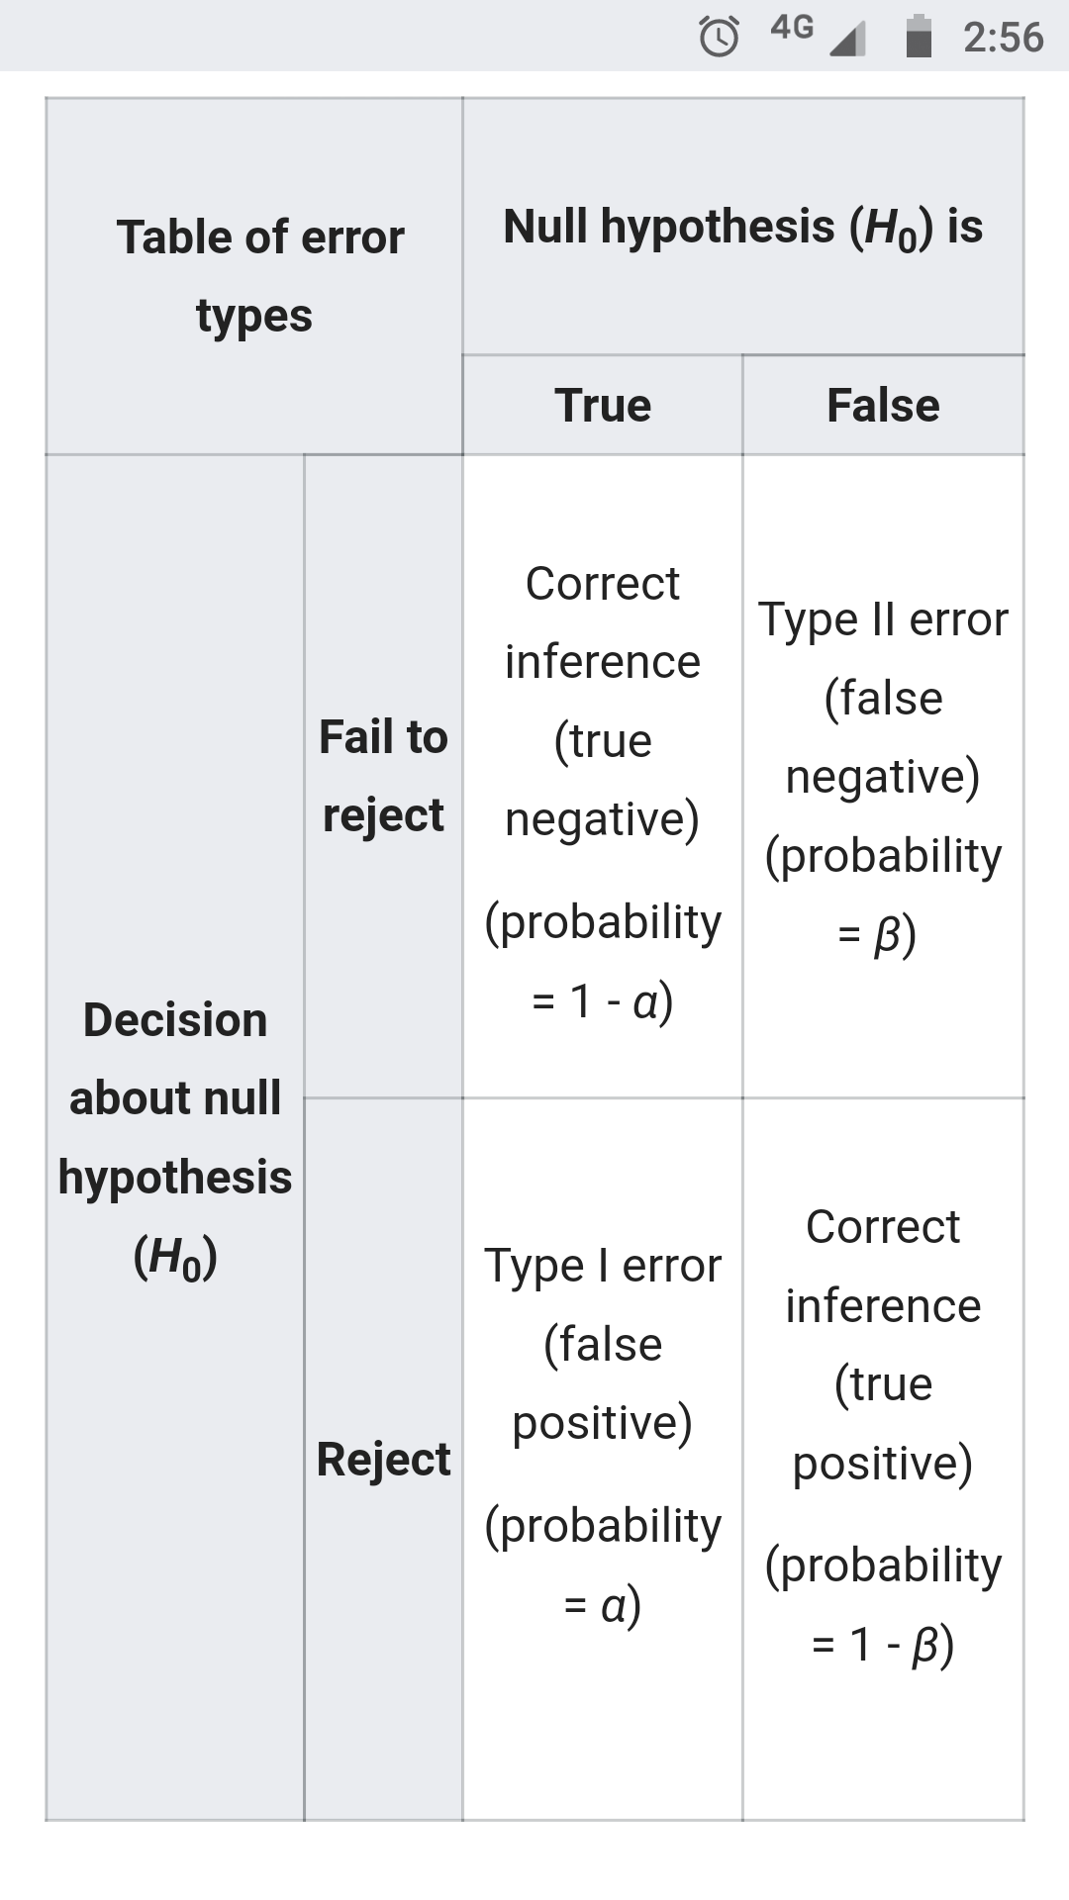

Now let's see the example problem for identifyin the type1 and Type2 error.

